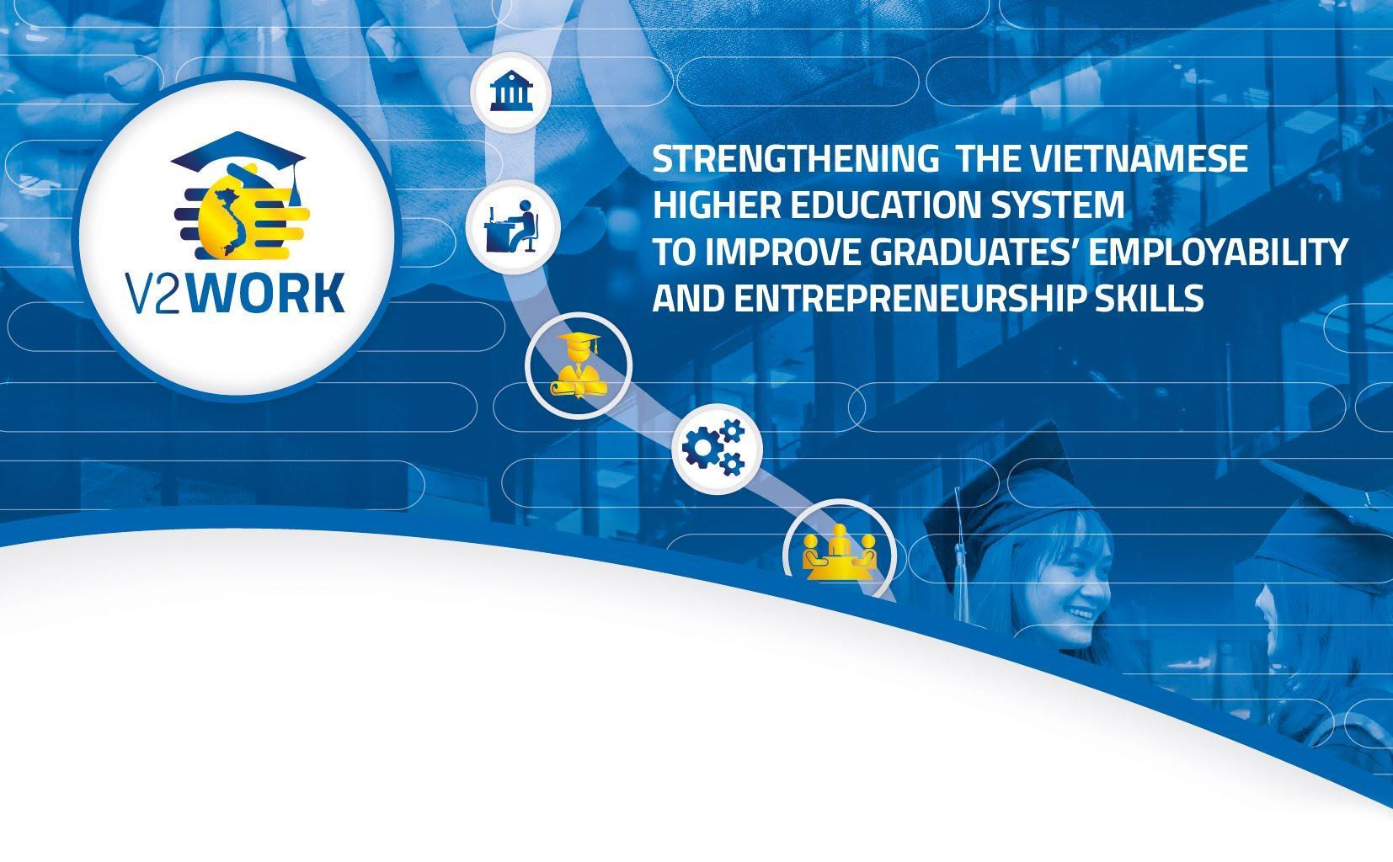
“Working together to promote student employability
& entrepreneurship in Vietnam”

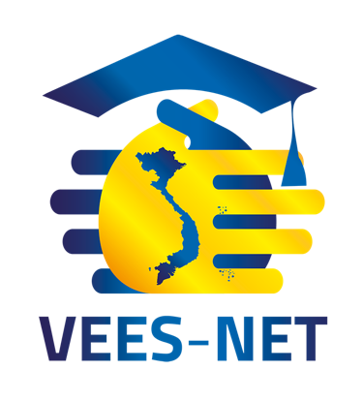
The V2WORK FINAL CONFERENCE
& 1st VEES-Net ANNUAL MEETING

Date: March 29th – 31st, 2021
Venue: Galina Nha Trang Hotel and Spa
Nha Trang, Vietnam

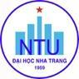
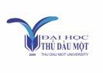
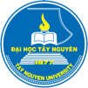
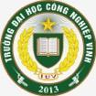
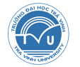
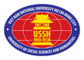
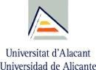

1. BACKGROUND
It is imperative that we support the development of our youth and provide them with the opportunities to make that future bright, because their future is our countries’ future. Globally countries that meet their youth’s needs will be in a better position in the second half of the century with more educated, healthier populations, more productive workforces & growing economies (State of the World Population, 2014). In Vietnam, the General Statistics Office and International Labour Organisation has reported that graduates struggle to find suitable work, appropriate to their experience and education (ILO 2015), in large part due to a “skills shortage” and a “skills gap” making recruitment difficult for employers (World Bank, 2014). This is compounded further by the social and economic impact of the Covid-19 pandemic which is being felt on a global scale, with youth being particularly vulnerable due to the loss of entry-level jobs, as well as internships and apprenticeships, running the risk of losing touch with the labour market and becoming marginalised in informal or precarious jobs (ILO, 2020).
But employment is not the only path open to a young graduate. He or she could also decide to start their own business venture and through its successful development and growth could help further develop the country’s economy and create new jobs. The idea of starting up their own business is attractive to Vietnam’s youth, and in the country entrepreneurs are well respected, although more support for the development of entrepreneurial activities is needed, in particular training programs aimed at younger people.
Within this context, the Erasmus+ project V2WORK “Strengthening the Vietnamese Higher Education System to improve graduates’ employability and entrepreneurship skills” was launched in October 2017 with the objective of strengthening the capacities of the Vietnamese HE System to improve the employability & entrepreneurship skills of its graduates, and to reinforce its relationships with the labour market, in line with the Vietnamese government’s priority of improving graduate employment at a national level. Over the course of 3.5 years, and with the active cooperation between eight Vietnamese universities, MOET, VCCI, student association AIESEC and 3 European universities, V2WORK has:
- Modernised career support services of & Vietnamese HEIs by building institutional & human capacities in employability and entrepreneurship skills to help them become efficient & dynamic instruments to promote & support employment & entrepreneurship among HEI students & graduates.
- Reinforced university-enterprise relationships through the development of mechanisms to foster active involvement of enterprises in the Career Centres.
Find out more about V2WORK at www.v2work.eu

2. OBJECTIVES & EXPECTED RESULTS OF THE V2WORK FINAL CONFERENCE & 1st VEES-Net ANNUAL MEETING
The V2WORK Final Conference & 1st VEES-Net Annual Meeting wants to be a platform to exchange views and experiences on supporting higher education students’ and graduates’ efforts to improve their employability and take their first steps on the path to becoming a successful entrepreneur.
Over the course of two days representatives of universities, policy makers and the labour market will come together to hear from universities from all around Vietnam about the work they are doing to support their students and graduates, and to discuss how the universities can cooperate at a national level, and how universities, employers and government can work together to on this issue. Participants will have ample opportunities for discussion and learning about each other’s work during the Networking Poster Sessions.
A third day will be reserved for working sessions for members of VEES-Net, the Vietnam Employability and Entrepreneurship Support Network, to continue the development of this new network.
Find out more about VEES-Net at www.vees-net.com

3. PARTICIPANTS
The V2WORK FINAL CONFERENCE & 1st VEES-Net ANNUAL MEETING is aimed at the university community (managers, professors, career centre staff), as well as at employers and policy makers. Participants will come together from all around Vietnam to showcase their experience and good practices in supporting student employability and entrepreneurship, and in discussing at length how the different groups of stakeholders and cooperate to continue improving their efforts.
The event is open to the public, but as there are limited spaces available anyone interested in attending should request an invitation from Nha Trang University.

AGENDA
DAY 1: March 29th, 2021
09.00 | MEETING OF THE V2WORK PARTNERS
12.00 | LUNCH
13.30 | Arrival and registration of participants, set up of posters.  MC: Luong Dinh Duy (NTU) & Tong Thi Lan Chi (TNU)
14.00 | WELCOME SPEECH  Dr. Khong Trung Thang, Chairman of the University council, NTU
14.15 | The V2WORK project  Ms. Cristina Beans, V2WORK coordinator, University of Alicante
14.45 | Congratulation Speech by the MOET  Deputy Minister of MOET
15.00 | Keynote 1: THE EMPLOYMENT SITUATION OF VIETNAMESE GRADUATES IN RECENT YEARS  Dr. Hoang Cong Dung, Deputy Director of Center of Training and Supplying Human Resources, MOET
15.30- 16.00 | COFFEE BREAK & NETWORKING POSTER SESSION
16.00 | Keynote 2  Dr Gary Wood, Head of Sheffield Engineering Leadership Academy, The University of Sheffield
16.20 | Other presentation by EU partners
16.40 | ROUND TABLE “IMPACT OF THE V2WORK PROJECT ON EMPLOYABILITY, EMPLOYMENT & ENTREPRENEURSHIP IN THE PARTNER UNIVERSITIES”  - USSH – Dr. Le Hoang Dung (Vice Rector)  - TVU – Dr. Nguyen Minh Hoa (Vice Rector)  - TDMU – Dr. Ngo Hong Diep (Vice Rector)  - NTU – Dr. Khong Trung Thang (University Council Chairman)  - TNU – Assoc.Prof. Tran Trung Dung (Vice Rector)  - IUV – Dr. Tran Manh Ha (Acting Rector)  - HUST – Assoc.Prof. Nguyen Phong Dien (Vice President)  - UD – Assoc.Prof. Vo Trung Hung (Vice Rector)  Moderator: Assoc.Prof. Dinh Van Hai (HUST)
17.30 | Day 1 Wrap-up: MC Tong Thi Lan Chi (TNU)
18:00 | Cocktail

DAY 2: March 30th, 2021
08.45 | ARRIVAL & REGISTRATION OF PARTICIPANTS
09.00 | OPENING & WELCOME  MC. Do Quoc Viet (NTU)  Opening speech: Assoc.Prof. Nguyen Phong Dien, HUST Vice President
9:15 | Speech by Department of Student Affairs, MOET  Mr. Bui Van Linh, Director of Student Affairs Office, MOET
09.45 | Speech by Local government and business:  COOPERATION BETWEEN BUSINESS COMMUNITIES AND HEIs IN SUPPORTING STUDENTS’ EMPLOYABILITY AND ENTREPRENEURSHIP  Dr. Vuong Vinh Hiep, Vice-Chairman of Khanh Hoa Business Association,  General Director of Long Sinh Co. LTD.
10.15 | COFFEE BREAK & NETWORKING POSTER SESSION
10.45 | Keynote 3: OPPORTUNITIES FOR STUDENTS AND YOUNG ENTREPRENEURS IN THE ERA OF 4.0 REVOLUTION  Mr. Vu Van Truc, Vietnam Dell Consumer Lead, Dell Technology  Business representatives
11.15 | ROUND TABLE "HOW TO WORK TOGETHER?”  Representatives of MOET, Universities, Employers, Local authorities  - Mr. Bui Van Linh (MOET)  - Dr. Khong Trung Thang (NTU)  - Dr. Le Hoang Dung (USSH)  - Ms. Bui Thi Ninh, VCCI HCMC  - Mr. Vu Van Truc, Vietnam Dell Consumer Lead, Dell Technology  - Dr. Vuong Vinh Hiep, Vice-Chairman of Khanh Hoa Business Association, General Director of Long Sinh Co. LTD  - One-non partner HEI representative (to be confirmed)  Moderator: Do Quoc Viet (NTU)
12.30 | LUNCH
1st VEES-Net ANNUAL MEETING – PUBLIC PLENARY SESSION
“SHARING OUR EXPERIENCES”
14.00 | INTRODUCING VEES-NET  Chaired by Assoc.Prof. Dinh Van Hai (HUST)
14.30 | Presentations on good practices of V2Work Project & VEES-Net:  - Entrepreneurship support at TDMU (Ms. Truong Thi Thuy Tien, TDMU)  - Employability and Employment support at TVU (Mr. Nguyen Duy, TVU)
15.30 | COFFEE BREAK & NETWORKING POSTER SESSION
16.00 | ROUND TABLE "HOW UNIVERSITIES CAN WORK TOGETHER”  - HUST: Assoc.Prof. Nguyen Phong Dien  - IUV: Dr. Tran Manh Ha  - UD: Assoc.Prof. Vo Trung Hung  - NTU: Dr. Khong Trung Thang  - TNU: Assoc.Prof. Tran Trung Dung  - USSH: Dr. Le Hoang Dung  - TDMU: Truong Thi Thuy Tien  - TVU: Dr. Nguyen Minh Hoa  Moderator: Assoc.Prof. Dinh Van Hai
17.30 | Day 2 Wrap-up: MC Assoc.Prof. Dinh Van Hai

DAY 3: March 31st, 2021
1st VEES-Net ANNUAL MEETING – MEMBERS ONLY WORKING SESSION
“PLANNING FOR THE FUTURE”
08.00 | ARRIVAL & REGISTRATION OF PARTICIPANTS
08.10 | OPENING & OBJECTIVES OF THE WORKING SESSION  MC: Assoc.Prof. Tran Le Hoa Tranh  Opening speech: Assoc.Prof. Nguyen Phong Dien
08.20 | PLANNING FOR THE FUTURE: Presentation, final changes & approval to the VEES-Net 2021-2023 Strategic Plan and the 2021 Action Plan  WORKING TOGETHER FOR THE FUTURE (1): Career Day  Assoc.Prof. Dinh Van Hai (HUST)
09.15 | WORKING TOGETHER FOR THE FUTURE (2): Cooperating to develop joint online courses  Tong Thi Lan Chi (TNU)
10.00 | COFFEE BREAK
10.20 | GROWING VEES- NET: New Members recruitment criteria & VEES-Net Marketing Plan  Ngo Thi Ngoc Hoa (UD)
11.00 | WORKING TOGETHER FOR THE FUTURE (3): Organizing VEES-Net Employment and Entrepreneurship Ecosystem Forum  Truong Thi Thuy Tien (TDMU) and Do Quoc Viet (NTU)
12.00 | 1st VEES-Net Annual Meeting Wrap-up:  MC: Assoc.Prof. Tran Le Hoa Tranh
12.15 | END OF CONFERENCE  Closing: Assoc.Prof. Nguyen Phong Dien

